SIMATS ENGINEERING
ASSESSMENT TOOL 2

COURSE NAME: Artificial Intelligence COURSE CODE: CSA1708

COURSE OUTCOME COVERED

CO2: Experiment search and game-solving techniques such as Greedy Search, A*, CSP, Minimax, and Alpha-Beta pruning with heuristic functions for solving complex AI problems efficiently. (BL3)

Assessment Tool Weightage: 50%

Duration: 1 Hour
QUESTIONS: 5 Total Marks:50

Annexure A

Scenario Based Assignment

Code of Conduct:

I SAJEEV IB(192312240)(Name / Reg No) certify that this submission is my original work and that I have adhered to the guidelines specified for this assessment.
I understand that any violation of academic integrity rules will result in disciplinary action.

Signature of the student:

Annexure A

Scenario Based Assignment

1. Scenario : A government deploys AI-powered drones to deliver emergency medicines in a flood-affected region. The environment is highly dynamic—roads may suddenly become inaccessible, and weather conditions affect travel cost. The drone has access to: A heuristic estimate (straight-line distance), Partial real-time updates about blocked paths and Variable movement costs depending on terrain and weather. However, due to urgency, the drone must quickly decide routes with minimum delay and risk.
Tasks:
- Explain how Greedy Best-First Search would behave in this scenario and discuss its strengths and weaknesses under uncertainty
- Explain how A* would handle the same situation, including how it balances cost and heuristic
- Analyze the impact of heuristic accuracy on both algorithms
- Discuss how dynamic changes (blocked paths) affect search performance
- Recommend the most suitable algorithm and justify your decision considering real-time constraints, optimality, and safety
2. Scenario: A smart city implements an AI system to optimize traffic signal timings across hundreds of intersections. The objective is to minimize Total waiting time, Fuel consumption and Traffic congestion. The system must continuously adjust signals based on traffic flow. However the search space is extremely large, traffic patterns change dynamically and the system may get stuck in locally optimal solutions
Tasks. Formulate this as an optimization problem and explain why traditional search is inefficient
- Explain how Hill Climbing would work in this scenario and identify its limitations
- Discuss issues like local maxima, plateaus, and ridges with real-world interpretation
- Explain how Simulated Annealing or Genetic Algorithms can overcome these limitations
- Recommend the best approach and justify your choice based on scalability and adaptability
3. Scenario: An autonomous rover is deployed on Mars to explore unknown terrain. It must: navigate safely to collect samples, avoid hazards (craters, rocks), operate with limited sensing capability and make decisions without a complete map. The rover updates its knowledge as it explores, making this a real-time decision-making problem.
Tasks:
- Explain why this problem requires an online search agent instead of offline search
- Analyze the challenges of partial observability and dynamic environments
- Describe how the rover builds and updates its internal model
- Compare online search with uninformed and informed search strategies
- Justify the most suitable approach considering uncertainty, adaptability, and safety
4. Scenario: A university is designing an AI system to automatically generate exam timetables. The system must satisfy multiple constraints: No student should have overlapping exams, Limited number of exam halls, Certain subjects must be scheduled before others, Faculty availability constraints, Special accommodations for some students, The complexity increases as the number of courses and students grows.
Tasks :
Formulate the problem as a Constraint Satisfaction Problem (CSP)
- Clearly define variables, domains, and constraints with explanation
- Explain how backtracking search works in this scenario
- Discuss how constraint propagation (e.g., forward checking) improves efficiency
- Analyze real-world challenges and justify the best strategy for scalability

5. Scenario: Strategic Game AI for Real-Time Decision Making (Minimax & Alpha-Beta Pruning) A gaming company is developing an AI opponent for a real-time strategy game. The AI must complete against human players, Make decisions within strict time limits, Evaluate complex game states with multiple possible moves, The decision tree is extremely large, making computation expensive.
Tasks:
- Explain how the Minimax algorithm models this problem
- Analyze the computational challenges of large game trees
- Explain how Alpha-Beta pruning improves efficiency with detailed reasoning
- Design an evaluation function and justify the factors considered
- Recommend a strategy for balancing optimality and real-time performance

RUBRICS FOR CALCULATION

Criteria | Weightage (%) | Level 4 (Exemplary) | Level 3 (Proficient) | Level 2 (Developing) | Level 1 (Beginning)
Understanding of Scenario | 20% | Demonstrates clear and complete understanding of the scenario and context | Shows good understanding with minor gaps | Partial understanding; misses key aspects | Misinterprets or fails to understand the scenario
Identification of Key Issues | 20% | Accurately identifies all relevant issues and factors involved | Identifies most key issues with minor omissions | Identifies limited issues; some irrelevant points | Unable to identify key issues
Application of Concepts | 25% | Applies appropriate concepts effectively to address the scenario | Applies concepts with minor errors | Limited or partially correct application | Unable to apply relevant concepts
Decision Making | 20% | Makes well-reasoned, logical decisions with strong rationale | Makes reasonable decisions with some justification | Makes weak decisions with limited justification | No clear decisions made or rationale provided
Clarity of Response | 15% | Response is clear, structured, and logically presented | Generally clear with minor issues | Somewhat unclear or poorly structured | Disorganized and difficult to understand

QUESTION 1 Search Under Uncertainty — Flood-Relief Drone Routing

SCENARIO
A government deploys AI-powered drones to deliver emergency medicines in a flood-affected region. Roads may suddenly become inaccessible and weather affects travel cost. The drone has a heuristic estimate (straight-line distance), partial real-time updates about blocked paths, and variable movement costs. It must decide routes quickly, minimising delay and risk.

i. Behaviour of Greedy Best-First Search
Greedy Best-First Search (GBFS) selects the next node to expand purely on the heuristic value h(n) — the estimated straight-line distance to the flood zone — while completely ignoring the actual path cost g(n) already incurred. In this scenario, the drone would always move towards whichever waypoint looks geographically closest to the destination, without weighing terrain difficulty, weather-related cost, or the risk of hitting a blocked road.
Strengths
- Very fast — expands far fewer nodes than exhaustive search, which matters when the drone must decide within seconds.
- Low memory and computation overhead, suitable for onboard embedded hardware with limited processing power.
- Works reasonably well when the heuristic is accurate and the environment is largely static.
Weaknesses under uncertainty
- Not optimal — it can commit to a route that looks short in straight-line terms but is actually blocked or far more costly once weather and terrain are factored in.
- Not complete in general graphs — it can get trapped oscillating toward a dead end (e.g., a blocked road) since it never reconsiders cost already spent.
- Highly sensitive to heuristic quality — a misleading heuristic near a flooded/blocked segment can strand the drone or force a costly late replan.
- Cannot gracefully react to dynamic blockage — once committed to the 'closest-looking' direction, it has no cost-based cushion to fall back on.

ii. How A* Handles the Same Situation
A* Search evaluates every candidate node using f(n) = g(n) + h(n), where g(n) is the actual accumulated cost of the path so far (real terrain and weather cost) and h(n) is the straight-line-distance heuristic to the goal. This balances 'how far have I already paid to get here' against 'how far do I still likely have to go'. Because A* keeps a priority queue ordered by f(n) rather than h(n) alone, it will happily choose a route that looks slightly longer in a straight line if it is cheaper and safer in real terms — for example, detouring around a blocked bridge instead of greedily flying straight at it.
- If the heuristic is admissible (never overestimates the true remaining cost) and consistent, A* is guaranteed to find the optimal (minimum-cost) route.
- When a path becomes blocked, A* re-evaluates using updated g-values and can re-expand alternative nodes already in its frontier rather than being stuck.
- It naturally trades off delay (through g) against urgency/distance (through h), which matches the requirement to minimise both delay and risk.
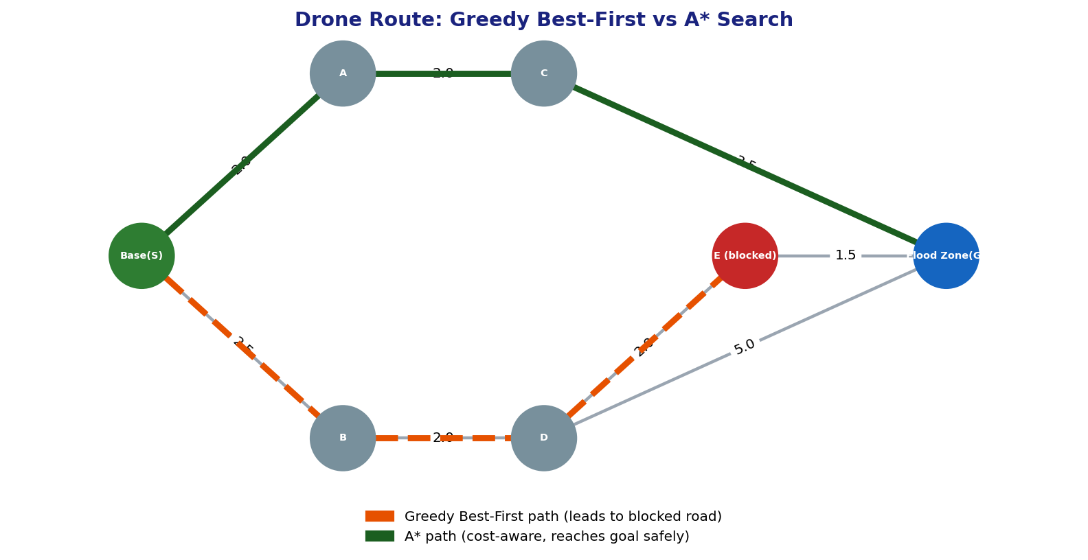
Figure 1: Greedy Best-First is lured toward the geometrically closest route and reaches a blocked road, while A* balances real travel cost with the heuristic and reaches the flood zone safely.

iii. Impact of Heuristic Accuracy on Both Algorithms
Heuristic Quality | Effect on Greedy Best-First | Effect on A*
Highly accurate (close to true cost) | Performs almost optimally and very fast, since h(n) alone approximates the right direction. | Performs near-optimally with very few node expansions — best case for A*.
Admissible but loose (underestimates a lot) | Can be badly misled toward dead ends; ignores real cost entirely. | Still guarantees optimality, but explores more nodes and is slower.
Inadmissible (overestimates) | No optimality guarantee anyway; may still find a fast but poor route. | Optimality guarantee is lost; may return a suboptimal or unsafe route quickly.
In short, Greedy Best-First's entire behaviour lives or dies by the heuristic since it is the only thing driving the search, whereas A* is more robust: an imperfect heuristic mainly costs A* extra computation, not correctness — provided admissibility is preserved.

iv. Effect of Dynamic Changes (Blocked Paths)
- Greedy Best-First has no mechanism to reconsider committed decisions — a newly blocked road discovered mid-flight forces a full restart from the current position, wasting the 'progress' already made toward the misleading heuristic direction.
- A* maintains an open list of alternative frontier nodes with known g-values; when new blockage information arrives, the affected edges can be re-costed (or set to infinity) and A* simply continues expanding the next-best f(n) node — closer to an incremental replan than a total restart.
- Both algorithms assume a mostly known environment; for a truly dynamic map, the practical implementation would be Real-Time A* / D* Lite style replanning, which still relies on A*'s cost-plus-heuristic evaluation as its core.
- Partial observability means the drone must re-plan repeatedly, so an algorithm that reuses previous search effort (A*-based) is far more efficient than one that must effectively restart (pure greedy).

v. Recommendation
A* Search is the more suitable algorithm for this flood-relief drone scenario. Although Greedy Best-First is faster per decision, its lack of an optimality guarantee and its vulnerability to blocked paths make it risky when human lives and medicine delivery timing are at stake. A* balances the urgency (through the heuristic component) with real-world safety and cost (through the path-cost component), and it degrades gracefully rather than catastrophically when the heuristic is imperfect or the map changes. For strict real-time constraints, this can be tuned with Weighted A* (inflating h(n) slightly) to trade a small amount of optimality for extra speed — retaining most of A*'s safety while approaching Greedy's responsiveness.

QUESTION 2 Local Search for Smart-City Traffic Optimisation

SCENARIO
A smart city implements an AI system to optimise traffic signal timings across hundreds of intersections to minimise total waiting time, fuel consumption and congestion. Signals must be adjusted continuously, the search space is extremely large, traffic patterns change dynamically, and the system may get stuck in locally optimal solutions.

Problem Formulation & Why Traditional Search Is Inefficient
- State: a complete assignment of green/red timing durations and phase offsets to every intersection's signal.
- Objective function: a weighted combination of total vehicle waiting time, fuel consumption, and congestion level — to be minimised (equivalently, maximise the negative of this cost).
- Search space size: with hundreds of intersections, each having several continuous/discrete timing parameters, the combined state space grows combinatorially (exponential in the number of intersections), far too large to enumerate or search exhaustively.
- Traditional uninformed/systematic search (BFS, DFS, or even complete tree-based A*) needs to store or explore huge portions of this space and assumes a static goal test, which does not fit a problem where the 'best answer' constantly shifts with live traffic and where we only need a good configuration, not a proven-optimal path to a goal state.
- This is therefore best framed as a local/optimization search problem: start from some configuration and iteratively improve it using only the value of the objective function, not a fixed path to a target state.

i. How Hill Climbing Would Work — and Its Limitations
Hill Climbing starts from an initial signal-timing configuration and repeatedly moves to a neighbouring configuration (e.g., adjusting one intersection's green duration by a small step) if and only if that move improves the objective function. It keeps climbing until no neighbouring move improves things further.
- Limitation — Local maxima: the algorithm stops at the first configuration where no small change helps, even if a very different configuration elsewhere would be far better city-wide.
- Limitation — Plateaus: many neighbouring timing changes may produce no measurable improvement (flat regions of the objective), causing the search to wander or halt prematurely.
- Limitation — Ridges: improvements may require several coordinated changes across neighbouring intersections simultaneously; a search that only tweaks one variable at a time zig-zags inefficiently along such a ridge.
- Limitation — No backtracking or memory: once it commits to a configuration, it cannot undo a move to explore an alternative branch, so a single bad early choice can trap the whole city's signal plan in a mediocre state.
- Limitation — Poor fit for a dynamic objective: as traffic patterns shift in real time, a configuration that was a local peak an hour ago may no longer even be good, and Hill Climbing has no built-in exploration to notice better regions elsewhere.

ii. Local Maxima, Plateaus and Ridges — Real-World Interpretation
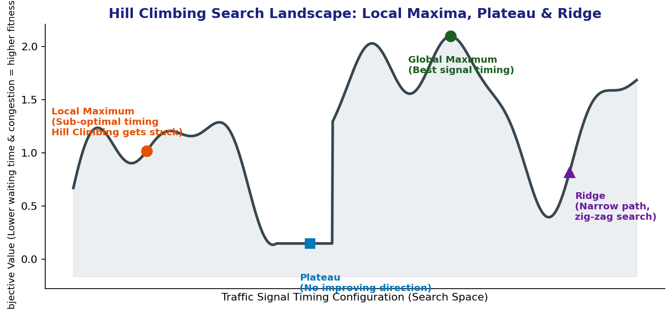
Figure 2: The traffic-timing search landscape contains a local maximum (a 'good enough' but sub-optimal timing plan), a plateau (many nearby plans performing identically), and a ridge (a narrow band of good plans reachable only through coordinated multi-signal changes) before the true global maximum.
Landscape Feature | Real-World Traffic Meaning
Local maximum | A signal-timing plan that reduces congestion at nearby junctions reasonably well, but a very different city-wide plan (e.g., coordinated 'green wave' timing) would perform much better overall.
Plateau | A stretch of timing adjustments (e.g., ±2 seconds at an already-quiet intersection) that make no measurable difference to waiting time, so the search has no gradient to follow.
Ridge | Situations where two or more adjacent intersections must be re-timed together (to create a synchronised 'green wave') — changing only one intersection at a time never shows enough benefit to be selected.

iii. Overcoming These Limitations
Simulated Annealing
Simulated Annealing behaves like Hill Climbing but occasionally accepts a worse move with a probability that depends on a 'temperature' parameter, which is gradually lowered over time. Early on (high temperature), it freely accepts worse signal-timing configurations, allowing it to escape local maxima, cross plateaus, and jump off ridges; as temperature cools, it settles into fine-tuning near a good solution — much like exploring broadly across the whole city's traffic patterns first, then refining specific intersections.
Genetic Algorithms
A Genetic Algorithm maintains a population of many candidate timing plans simultaneously. It combines (crossover) good partial plans from different candidates — e.g., merging a well-timed north corridor from one candidate with a well-timed east corridor from another — and randomly mutates some timings to maintain diversity. Because it explores many regions of the search space in parallel rather than a single point, it is naturally resistant to getting trapped in any one local maximum, and it can capture the coordinated multi-intersection changes needed to cross a ridge.

iv. Recommendation
For this smart-city traffic-signal problem, a Genetic Algorithm is the most suitable overall approach. Its population-based, parallel exploration scales naturally to hundreds of intersections and can represent coordinated 'green-wave' timing patterns across multiple signals as a single chromosome, directly addressing the ridge problem that single-point local search struggles with. Simulated Annealing is a strong, lighter-weight alternative — particularly useful for quickly re-optimising a subset of signals in near-real time once the city-wide plan has already been found by the GA, since it needs less memory and fewer parallel evaluations. In practice, a hybrid is common: a GA run periodically (e.g., every few minutes) to find a strong global timing plan, with Simulated Annealing or plain Hill Climbing used for fast, cheap, local adjustments in between as traffic shifts — balancing scalability and adaptability.

QUESTION 3 Online Search for an Autonomous Mars Rover

SCENARIO
An autonomous rover is deployed on Mars to explore unknown terrain. It must navigate safely to collect samples, avoid hazards (craters, rocks), operate with limited sensing capability, and make decisions without a complete map. The rover updates its knowledge as it explores, making this a real-time decision-making problem.

i. Why This Requires an Online Search Agent Instead of Offline Search
Offline search assumes the agent has complete knowledge of the environment (the full map/state space) before it starts acting, and it computes an entire solution path in advance before executing a single move. On Mars, the rover has no such map — the terrain, obstacles, and hazards are unknown until sensed, and communication delay (several minutes each way to Earth) rules out waiting for a fully pre-computed plan. An online search agent instead interleaves computation and action: it senses the immediate surroundings, decides the next action, executes it, observes the actual outcome, and only then plans the following step. This is the only viable model when the map must be discovered through acting rather than known in advance.

ii. Challenges of Partial Observability and Dynamic Environments
- Partial observability: the rover's sensors (cameras, LIDAR) only reveal terrain within a limited range, so hazards just beyond sensor range are unknown until the rover moves closer, risking dead ends or unsafe manoeuvres.
- Irreversible actions: some actions cannot be undone (e.g., driving into a crater or getting a wheel stuck), so the rover must be conservative and cannot simply 'backtrack' the way an offline search tree can freely explore and discard branches.
- Dynamic terrain: dust storms, shifting sand, and lighting changes mean the environment itself can change between observations, so knowledge gathered earlier may become stale.
- Communication latency with Earth means the rover cannot rely on a human operator for every decision — it must autonomously replan locally within its own limited horizon.
- Competing objectives: balancing safety (avoiding hazards) with mission efficiency (reaching sample sites quickly) under uncertainty increases decision complexity at every step.

iii. How the Rover Builds and Updates Its Internal Model
The rover maintains an internal map (often an occupancy grid or graph of visited/observed terrain cells) that starts largely empty except for its immediate surroundings. At each step it:
- Senses the local environment and marks newly observed cells as free, hazardous, or unknown.
- Updates cost estimates for terrain segments (e.g., steep slope = higher traversal cost) based on sensor data.
- Re-runs a local search (e.g., an online variant of A*, such as LRTA* — Learning Real-Time A*) over the currently known map to choose the next best action toward the sample-collection goal.
- Learns from experience: if an expected route turns out to be more costly than estimated (heuristic was optimistic), it updates its heuristic/cost table for that region so future decisions in the same area are better informed — this is the core idea behind LRTA*.
- Repeats this sense-plan-act loop continuously, gradually converging on a reliable internal map of explored regions while still treating unexplored regions as unknown.

iv. Online Search vs Uninformed and Informed (Offline) Search
Aspect | Uninformed Offline Search (e.g., BFS/DFS) | Informed Offline Search (e.g., A*) | Online Search (e.g., LRTA*)
Map knowledge required | Complete, known in advance | Complete, known in advance | Unknown / discovered incrementally
When planning happens | Entirely before acting | Entirely before acting | Interleaved with acting
Use of heuristic | None | Yes — guides expansion toward goal | Yes — heuristic refined through experience
Handles irreversible actions safely | Not designed for this | Not designed for this | Yes — designed for real-world commitment
Suitability for Mars rover | Impractical — no full map exists | Impractical — no full map exists | Appropriate — matches sense-act-replan cycle

v. Justification of the Most Suitable Approach
An online, informed search strategy such as LRTA* (Learning Real-Time A*) is the most suitable approach for the Mars rover. It combines the goal-directed efficiency of a heuristic (informed) search with the ability to act under partial observability and continuously update its internal model as new terrain is discovered — exactly matching the rover's constraints of uncertainty, limited sensing range, and the need for adaptability. Because it commits to real, physical moves rather than exploring a hypothetical search tree, it naturally respects the safety requirement of avoiding irreversible mistakes: the rover only takes the next cautious, locally-best step rather than assuming a long unverified plan is safe. This makes it far better suited than any offline strategy, which cannot function at all without a complete map that simply does not exist for unexplored Martian terrain.

QUESTION 4 Constraint Satisfaction for University Exam Timetabling

SCENARIO
A university is designing an AI system to automatically generate exam timetables, satisfying: no student has overlapping exams, a limited number of exam halls, certain subjects scheduled before others, faculty availability constraints, and special accommodations for some students. Complexity increases as the number of courses and students grows.

Formulating the Problem as a CSP
Variables, Domains and Constraints
Element | Definition in This Scenario
Variables | One variable per course/subject that has an exam to be scheduled, e.g., X1 = Data Structures exam, X2 = AI exam, X3 = Operating Systems exam, ...
Domains | For each variable, the domain is the set of possible (time-slot, exam-hall) pairs it could be assigned — e.g., {(Mon 9am, Hall A), (Mon 9am, Hall B), (Mon 2pm, Hall A), ...} restricted to slots when required faculty/invigilators are available.
Unary constraints | Constraints on a single variable, e.g., a course requiring special lab equipment can only take values whose hall supports it; a course needing extra time for accommodations can only use time-slots long enough.
Binary constraints | Constraints between pairs of variables, e.g., two courses sharing common students cannot be assigned the same time-slot (no overlap); Course A must be scheduled strictly before Course B (precedence).
Global / resource constraints | Constraints across many variables at once, e.g., the number of exams assigned to any single time-slot cannot exceed the number of available halls; a faculty member cannot invigilate two simultaneous exams.
The goal is to find a complete assignment of (time-slot, hall) pairs to every course variable such that every unary, binary, and global constraint is satisfied — this is a classic large-scale CSP.

ii. How Backtracking Search Works in This Scenario
Backtracking search assigns a value (a time-slot and hall) to one course at a time, following the order of variables. After each assignment, it checks whether the constraints affecting the already-assigned variables are still satisfied. If a conflict is found — for example, assigning Data Structures and AI to the same slot when they share enrolled students — the search backtracks: it undoes the most recent assignment and tries a different value from that variable's domain. This continues, depth-first, until either a complete valid timetable is found or all options are exhausted at some point, forcing further backtracking to an earlier variable.
- Variable ordering heuristics such as Minimum Remaining Values (schedule the most constrained subject — e.g., one with the most shared students across other courses — first) make backtracking far more efficient by failing fast on the hardest cases.
- Value ordering heuristics such as Least Constraining Value help pick a time-slot/hall combination that leaves the most options open for subjects still to be scheduled.

iii. How Constraint Propagation (Forward Checking) Improves Efficiency
Pure backtracking only detects a conflict after a bad assignment has already been made, which can waste significant search effort deep in the tree before failure is discovered. Forward checking improves this by, immediately after assigning a course's time-slot and hall, looking ahead at every not-yet-assigned course that shares a constraint with it (e.g., shares students, or has a precedence relationship) and removing now-invalid values from their domains. If any unassigned course's domain becomes empty as a result, the search backtracks immediately rather than continuing to build an assignment that is already guaranteed to fail.
- This detects failure much earlier, drastically pruning the search tree for large course catalogues.
- More advanced propagation (e.g., Arc Consistency / AC-3) can be applied before or during search to remove impossible time-slot/hall combinations for pairs of courses even before any assignment is made, shrinking the effective search space from the start.

iv. Real-World Challenges and Best Strategy for Scalability
- As the number of courses, students, and halls grows, the constraint graph becomes dense (many courses share students across a large curriculum), which increases both the difficulty of finding a solution and the cost of constraint checks.
- Special accommodations (extra time, separate quiet rooms) introduce additional unary/global constraints that further shrink usable domains for some courses.
- Faculty availability constraints add a second resource dimension (invigilators) layered on top of hall capacity, effectively turning this into a multi-resource scheduling CSP.
- Precedence constraints (some subjects before others) interact with time-slot ordering, which can create long dependency chains that are easy to violate accidentally.
For scalability, the recommended strategy is backtracking search combined with forward checking (or full arc-consistency preprocessing) and strong variable/value ordering heuristics (Minimum Remaining Values plus Least Constraining Value). This combination keeps the search tractable for realistically sized university timetables by detecting failure early and by intelligently prioritising the hardest-to-place courses first, rather than relying on brute-force backtracking alone, which would not scale as the number of courses and students grows.

QUESTION 5 Minimax & Alpha-Beta Pruning for Real-Time Game AI

SCENARIO
A gaming company is developing an AI opponent for a real-time strategy game. The AI must compete against human players, make decisions within strict time limits, and evaluate complex game states with multiple possible moves. The decision tree is extremely large, making computation expensive.

i. How the Minimax Algorithm Models This Problem
Minimax models the game as a tree in which the AI (the MAX player) and the human opponent (the MIN player) alternate turns. Each leaf node of the tree is assigned a value from an evaluation function representing how favourable that resulting game state is for the AI. Minimax recursively computes, for each internal node, the best value the MAX player can guarantee assuming the MIN player always plays to minimise that value (i.e., the opponent is assumed to play optimally against the AI). The AI then selects the move at the root that leads to the branch with the maximum guaranteed value, ensuring it makes the best decision under worst-case (optimal-opponent) assumptions.

ii. Computational Challenges of Large Game Trees
- Exponential growth: the number of nodes grows as O(b^d), where b is the branching factor (number of legal moves per turn) and d is the search depth — real-time strategy games often have very high branching factors, making full-depth search infeasible.
- Strict time limits: the AI must decide within a fixed real-time budget (often milliseconds), so it cannot afford to fully explore deep trees before acting.
- Memory constraints: storing large portions of the tree (or transposition tables of visited states) consumes significant memory, which is limited in real-time constrained environments.
- Evaluation cost: computing the evaluation function itself for complex game states (many units, resources, terrain) can be expensive, multiplying the cost of visiting each leaf.

iii. How Alpha-Beta Pruning Improves Efficiency
Alpha-Beta pruning enhances Minimax by tracking two bounds while traversing the tree: alpha (the best value the MAX player can already guarantee along the current path) and beta (the best value the MIN player can already guarantee along the current path). While exploring a MIN node's children, if a value is found that is less than or equal to alpha, the MIN player would never let the game reach this branch (since MAX already has a better guaranteed alternative elsewhere), so the remaining children of that node can be safely skipped — pruned — without ever being evaluated. The symmetric logic applies at MAX nodes with respect to beta.
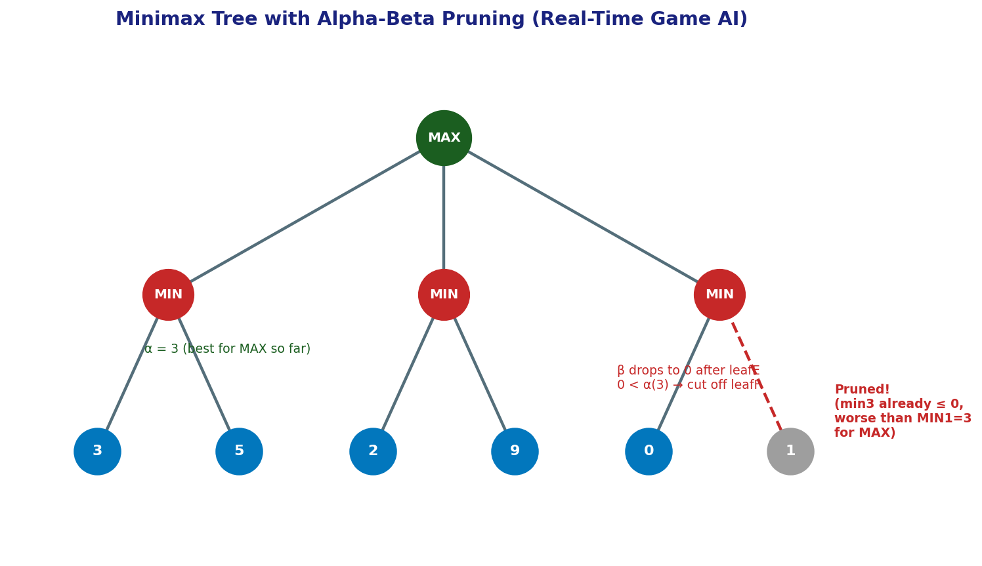
Figure 3: After exploring the first branch (values 3, 5), MAX has α = 3 guaranteed. In the third branch, MIN's first child evaluates to 0, already below α, so MIN will never allow this branch to be chosen — the second child is pruned without evaluation.
- Crucially, Alpha-Beta pruning returns exactly the same decision as full Minimax — it never changes the outcome, it only avoids wasted computation.
- With a good move-ordering heuristic (examining the most promising moves first), Alpha-Beta can reduce the effective branching factor from b to roughly √b, which in the best case lets the AI search to nearly double the depth in the same time budget compared to plain Minimax.
- This directly addresses the real-time constraint: more pruning means either faster decisions at the same depth, or deeper (stronger) look-ahead within the same time limit.

iv. Designing an Evaluation Function
Since the tree cannot be searched to a terminal (win/lose) state within the time budget, Minimax with Alpha-Beta is combined with a depth-limited search that applies a heuristic evaluation function at the cutoff depth instead of leaf nodes. A reasonable evaluation function for a real-time strategy game AI would combine several weighted factors:
- Material balance: the AI's total unit/resource strength minus the opponent's (e.g., unit count weighted by unit type strength).
- Territory / map control: number of key positions, resource points, or map area controlled by each side.
- Economic strength: resource-gathering rate and stockpiles, since these predict future strength beyond the current snapshot.
- Positional safety: exposure of valuable units/structures to attack, distance from defensive support.
- Tempo / mobility: number of available productive actions, reflecting flexibility and initiative.
Each factor is normalised and combined with tunable weights (e.g., learned via self-play or hand-tuned by designers) so the single evaluation score reflects overall favourability for the AI. These factors are chosen because they are cheap to compute from the game state directly, correlate well with actual win probability, and can be updated incrementally as the state changes during search.

v. Strategy for Balancing Optimality and Real-Time Performance
The recommended strategy is Minimax with Alpha-Beta pruning, combined with iterative deepening and a well-tuned depth-limited evaluation function. Iterative deepening runs Alpha-Beta at increasing depth limits (1, 2, 3, ...) within the time budget, always keeping the best move found at the deepest completed level — this guarantees the AI always has a legal, reasonably good move ready even if it is interrupted by the time limit, while still allowing deeper search when time allows. Move-ordering heuristics (trying previously good moves first, or using a transposition table) maximise the benefit of Alpha-Beta pruning, and the evaluation function absorbs the complexity that cannot be resolved through search depth alone. This combination gives the best practical balance: it preserves Minimax's sound decision-theoretic guarantees where computation allows full exploration, and it degrades gracefully to a strong heuristic-driven choice under strict real-time constraints, rather than failing to produce a move at all.

